What is the Difference between Sequential and Combinational Logic Circuits?
- Sequential has memory (i.e. Flip-Flops)
Counter:
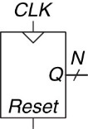

Flip-Flop – adds memory so we remember where we are where we have been
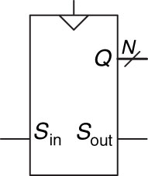
Shift Register:
- Creates a serial-to-parallel conversion
- Shifts into LSB and outputs 4-Bits (N-Bits) given a 4-Bit System

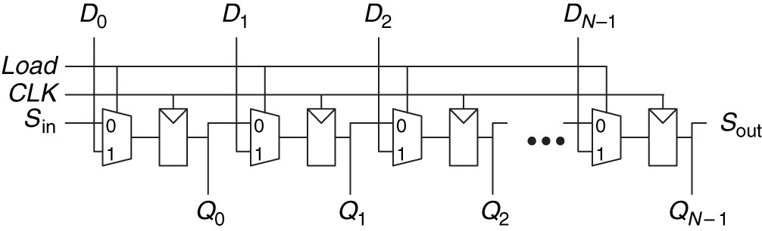

What is the difference between a Shifter and a Shift Register?
- A shifter is purely combinational logic
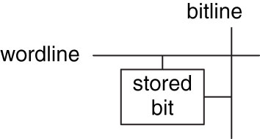
Memory
- Address – Indicates which row of memory is read/written (location) 2^{N} (N-Bits)
- Data – Value read/written M-Bits
- Word – size of row of data (M-Bits)
- Depth – Number of rows
- Width – Number of Columns
- Wordline – Assert based on address to activate bit cells in a row
- Bitline – kept at Z; when wordline is activated, driven to 1 or 0 by bit cell to read
  - When written , drives bit cell high or low
- Port – Gives read/write access to the address; multi-ported can read/write several addresses at the same time

Address –
Data –
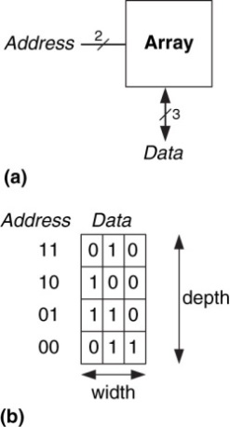
Word –
Depth -
Width –
Wordline –
Bitline –

Port –
ROM – Read Only Memory
    - Also randomly accessed
    - Many can be written now
    - Non-Volatile
RAM – Random Access Memory
    - Delay same for all addresses, vs sequential (e.g. type)
    - Volatile – Loses its data when the power is lost
Types of memory:
RAM –
ROM –
Types of RAM:  DRAM –  Pppppppp0 b m  DRAM – Dynamic RAM  - Bit stored as absence or presence of charge on a capacitor  - Reading destroys data; must be rewritten  - Must be refreshed every few miliseconds due to leaking charge  SRAM –  SRAM – Static RAM  - Does not need refreshing  - Bit stored in cross coupled inverters  - Inverters can restore value if noise interferes | Types of DRAM:  SDRAM –  SDRAM – Synchronous DRAM  - Uses pipelined memory access  DDR SDRAM – Double data rate SDRAM  - Uses Rising and falling edge to access data  DDR SDRAM –  - Larger memories tend to be slower  - More transistors = more size, power, and cost  - Best Memory depends on speed, cost, power constraints
  Memory Type | Transistors per bit cell | Latency
  Flip-Flop | ~20 | Fast
  SRAM | 6 | Medium
  DRAM | 1 | Slow
  Memory Type | Transistors per bit cell | Latency

Register file -
Register File – Group of registers that stores temporary variables
  - Often consists of small multiported SRAM

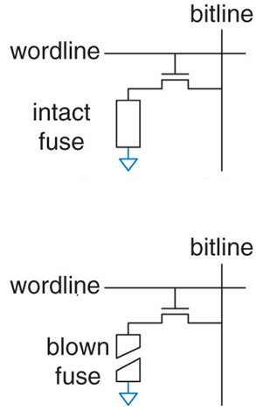
Types of ROM:
PROM
Fuse Programmable ROM
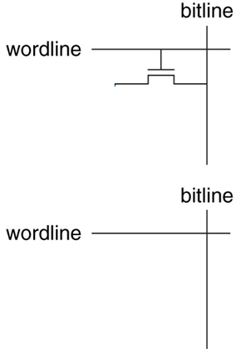
PROM –
PROM – Programmable Read only Memory– Provides a way to connect transistor with ground
Fuse Programmable ROM – blow fuse = 1, cannot be rewritten

Fuse-programmable ROM –
EPROM – Eraseable PROM
  - High voltage to write
  - UV light to erase

EPROM –
EEPROM – Electrically EPROM
  - Bit cells individually erased
  - Erased without UV light with extra circuitry

EEPROM –

Flash –
Flash – Large blocks erased
  - Cheaper because less erasing circuitry

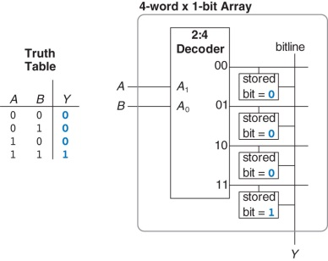
Logic using memory arrays:
Look Up Table!

